1.Используя **brick-standard**, вывод данных о товарах на **home-page** из **БД**:

**resources/views/shop/index.blade.php**

@include('shop.brick-standard')

**resources/views/shop/brick-standard.blade.php**

@foreach($products as $product)

<img src="{{ asset('public/img/' . $product->image) }}" alt="">

…{{ $product->price }}…

…{{ $product->name }}…

@endforeach

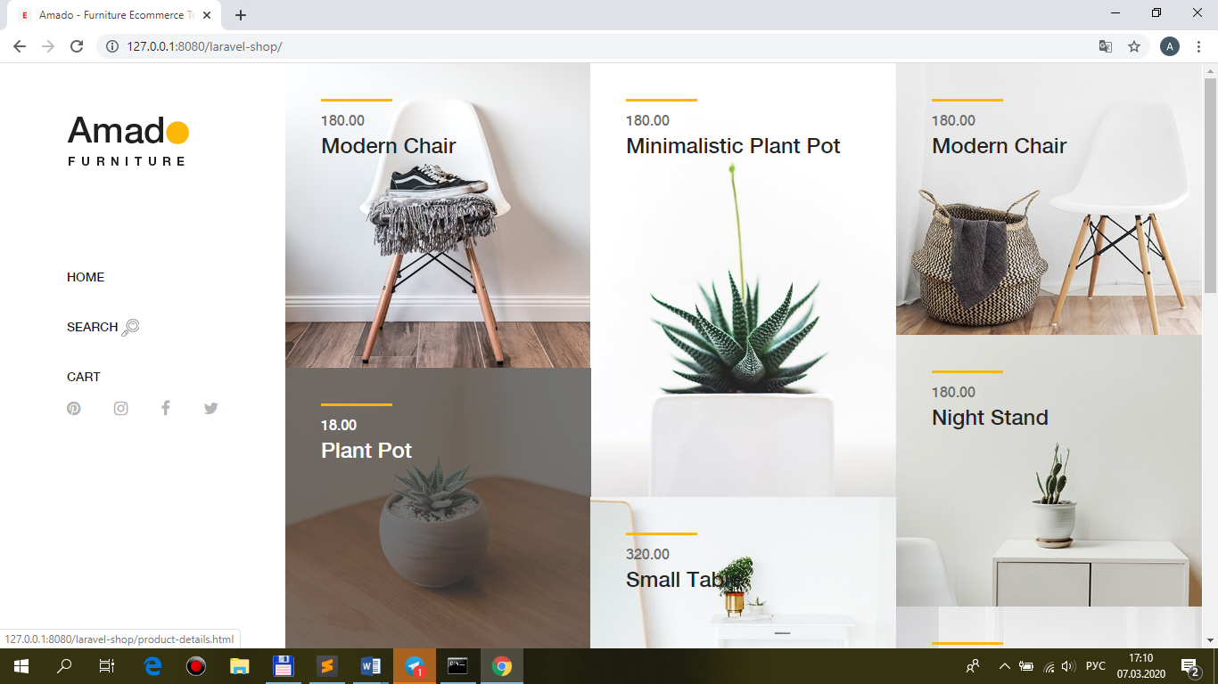

2.Используя **построитель запросов** **Eloquent**, вывод данных по **order by price asc**:

**app\Repositories\ShopRepository.php**

public function funcSelect($request)

{

$query = $this->model

->select('id', 'name', 'price', 'image')

**->orderBy('price', 'asc');**

return $query->get();

}

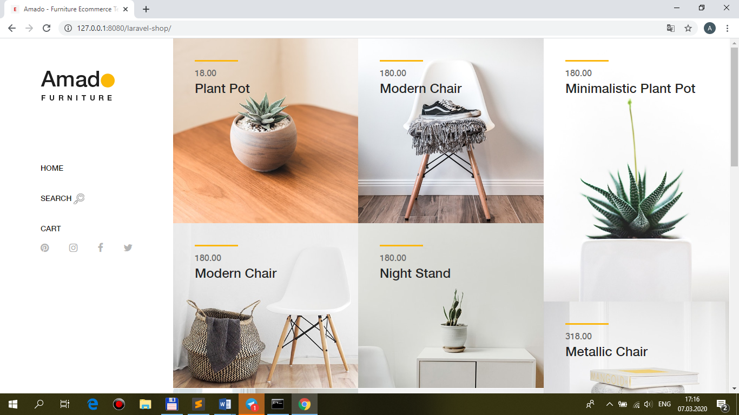

3.При **click** на **выбранный** товар на **home-page** – **переход** на **product-page** + **print_r** информации о **выбранном** продукте:

**resources/views/shop/brick-standard.blade.php**

<a **href="{{ route('product', [$product->id]) }}"**>

…

**routes\web.php**

Route::name('product')->get('/product**/{id}**', 'ShopController@product');

**app\Http\Controllers\ShopController.php**

use App\ {

Repositories\ShopRepository,

**Models\Product**

};

public function **product($id, Product $model_product)**

{

**$product = $model_product->find($id);**

return view('shop.product'**, ['product' => $product]**);

}

**resources/views/shop/product.blade.php**

@php

**print_r($product);**

@endphp

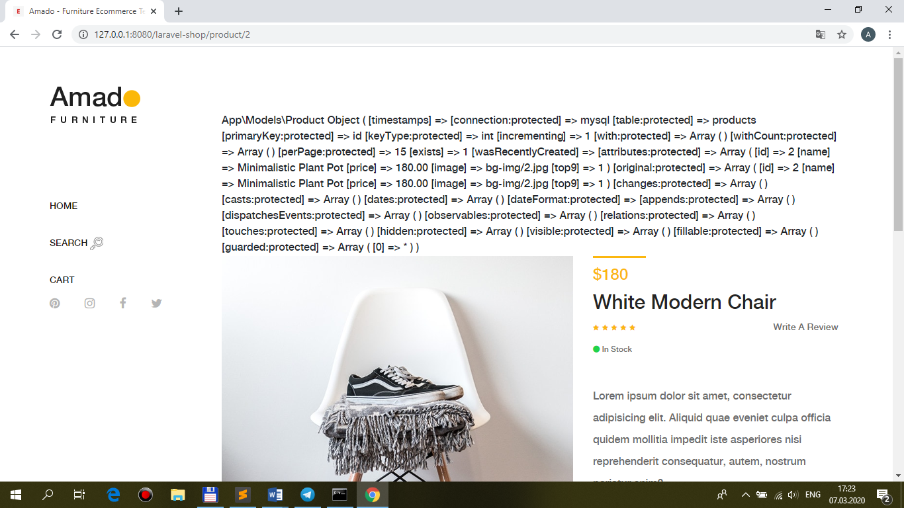

**+выведите image, name, price выбранного товара на страницу product**

<img src="{{ asset('public/img/' . **$product[0]->image**) }}" alt="" />

<p class="product-price">**{{$product[0]->price}}**</p>

<a href="product-details.html">

<h6>**{{$product[0]->name}}**</h6>

</a>

